DATA SCIENCE 3
MULTIRELATIONAL DATA MINING
https://github.com/alde1021/MIT-203-MRDM.git
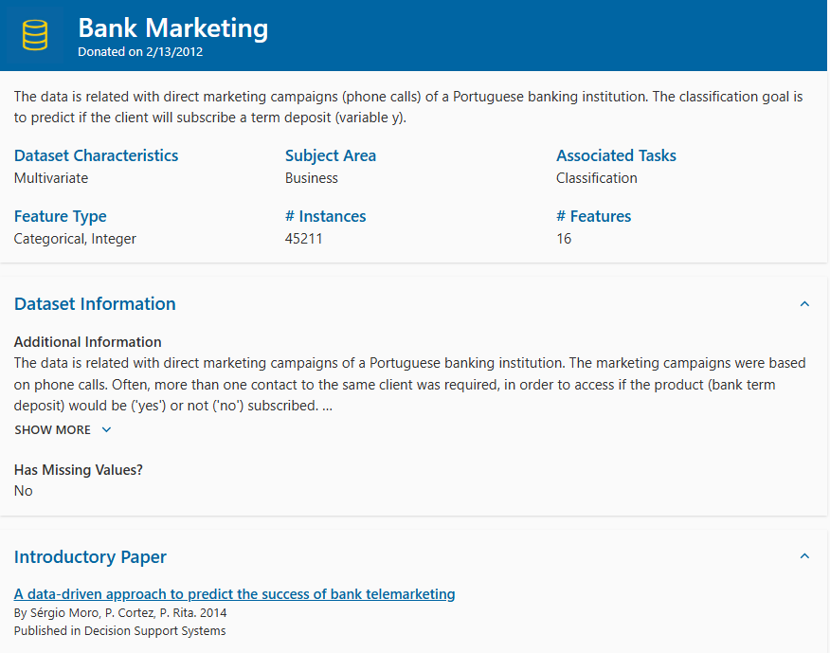
Step 1: Download Bank Marketing - UCI Machine Learning Repository

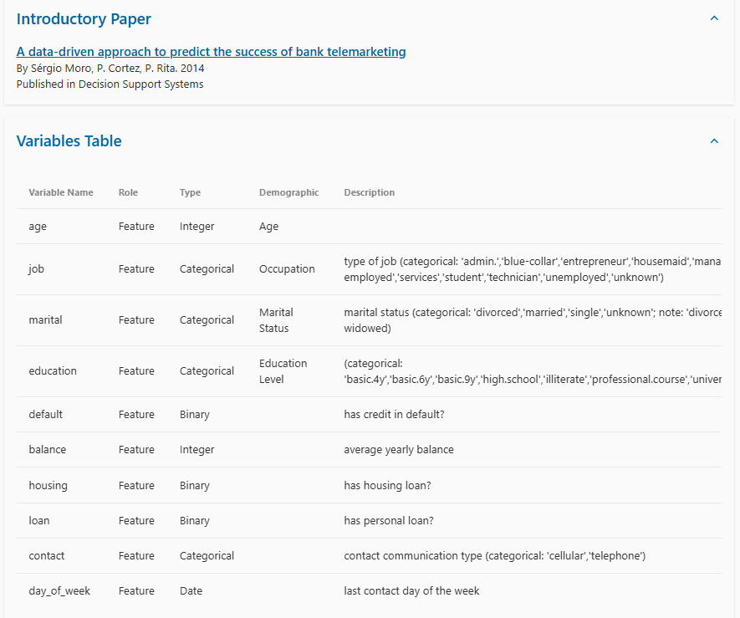

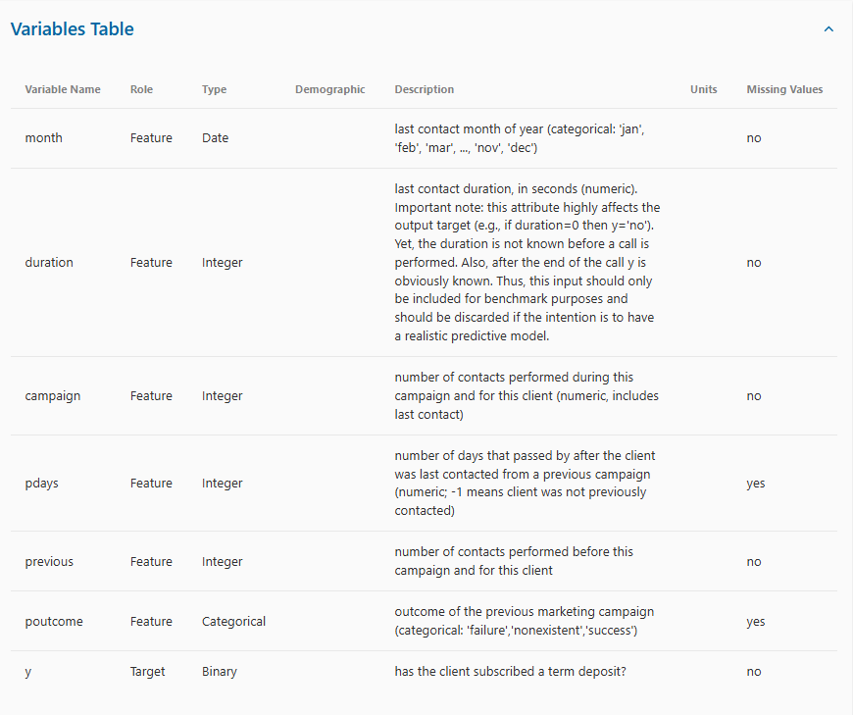

Step 2: Database Management Tool make sure to install this for creating database and to create relationships
Install DBeaver Download | DBeaver Community
Step 3: go to Jupyter and select CreateDB.ipynb then run all the codes
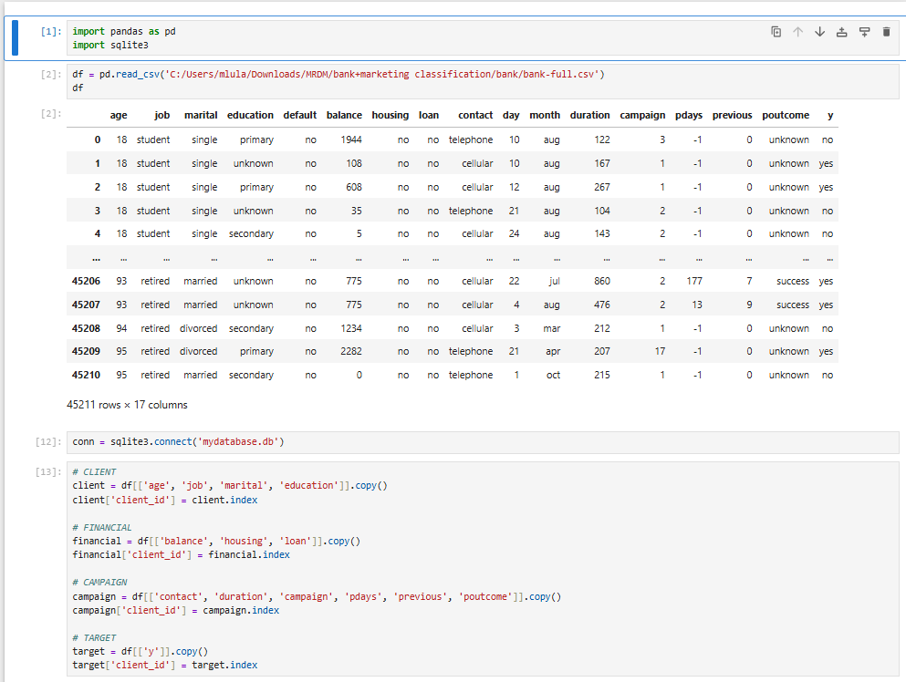

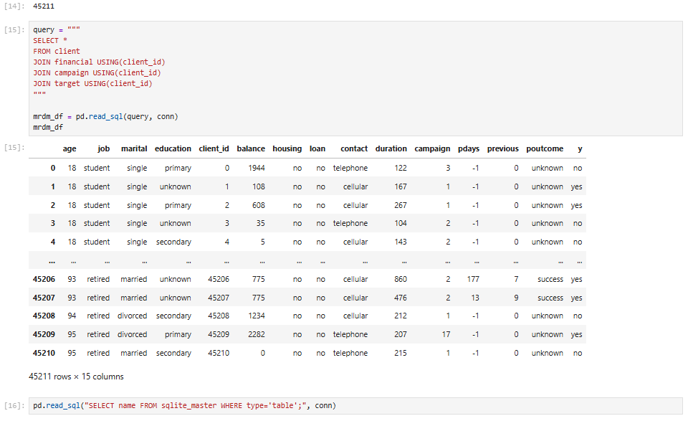
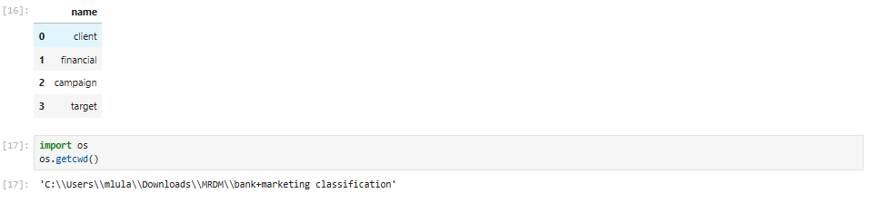
Step 4: go to DBeaver select Database then New Database Connection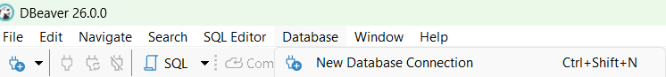
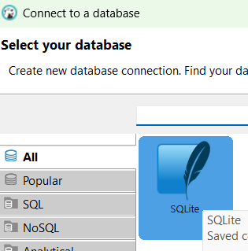
Choose SQLite

